**Guangxi Association website plan**

**Author:** liangjianquan

**Date:** 2022-11-09

Version 1.0

# Table of contents:

Overview 3

Design contains 3

Web page hierarchy diagram 3

show content 4

Navigation 5

Home 5

Association Blog 8

News and Events 8

Association members 9

Related Companies 10

Contact Us 10

Backstage Management 11

Technology 11

# Overview

# The Guangxi Association website aims to introduce the Association and showcase recent developments and news releases. The website includes the homepage, recent developments, and news. It also displays past activities of the Association, members of the Association, contact information, and Backstage Management.

# Design contains

The homepage of the website will introduce the Association's information, including its history, mission, and values. The recent developments and news section will keep the audience up-to-date with the latest events, important notices, and upcoming activities. A video will be displayed that showcases the Association's past events. Additionally, a blog will be created that highlights the latest activities of the Association.

# Web page hierarchy diagram

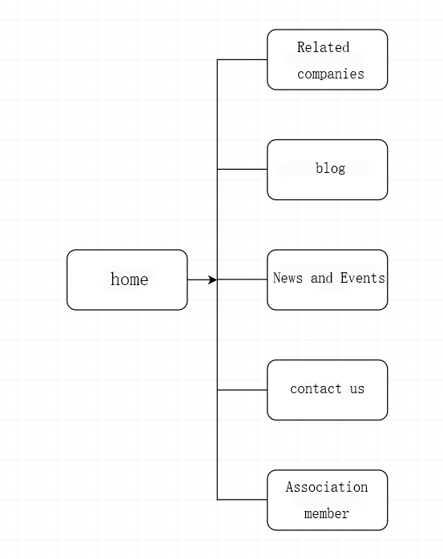

**Show content**

The name of the domain name applied by the association needs to be provided by the association. The following is the reference website content.

## Navigation

The navigation of the website will be simple and easy to use, consisting of Home, Blog, News and Events, Association Members, Related Companies, and Contact Us.

## Homepage

The association's mission, vision, and values will be introduced on the homepage.

## Showcase

The showcase section will include the latest news, videos, and events related to the Association. The news section will feature upcoming events, important notices, and other announcements.



## Video

The video section will showcase a video of the latest event hosted by the Association.

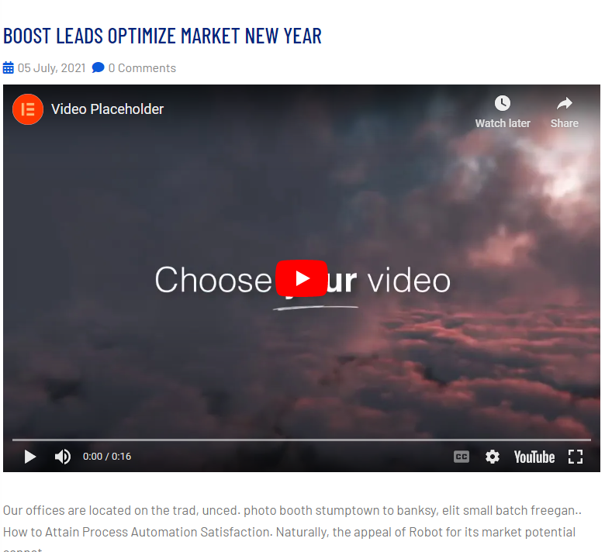

## Event

The events section will highlight the latest activities of the Association.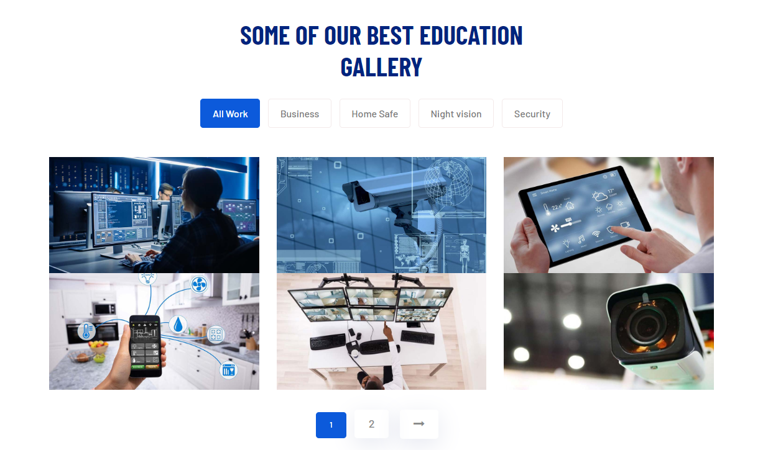

## Association Blog

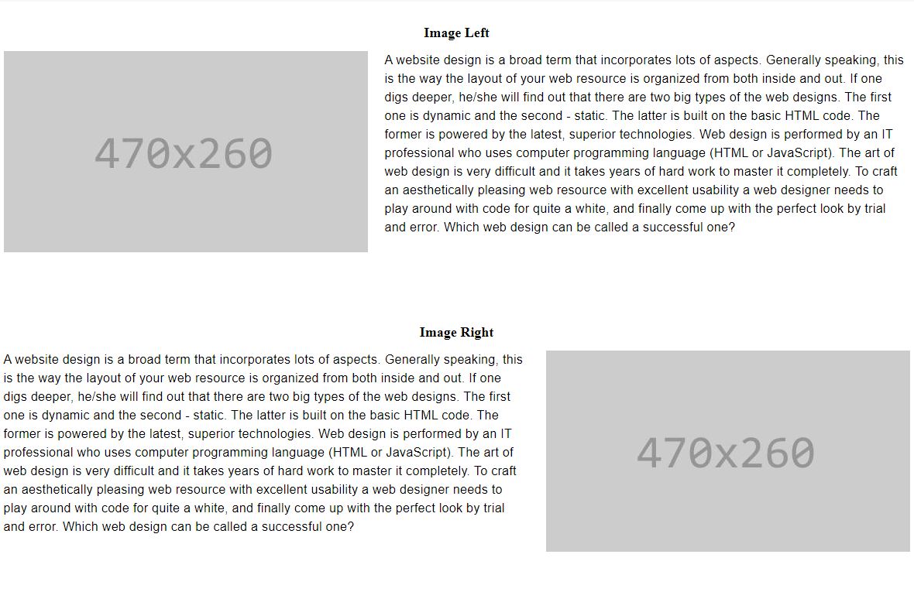The Association Blog will showcase the past activities of the Association. This section can be added backstage and will require the Association to provide previous activity documents and pictures. Past videos of the Association can also be added backstage, and the Association needs to provide relevant video links.

## News and Events

The News and Events section will feature the latest news, upcoming events, and important notices related to the Association. This section will keep the audience informed about the latest developments and activities of the Association.

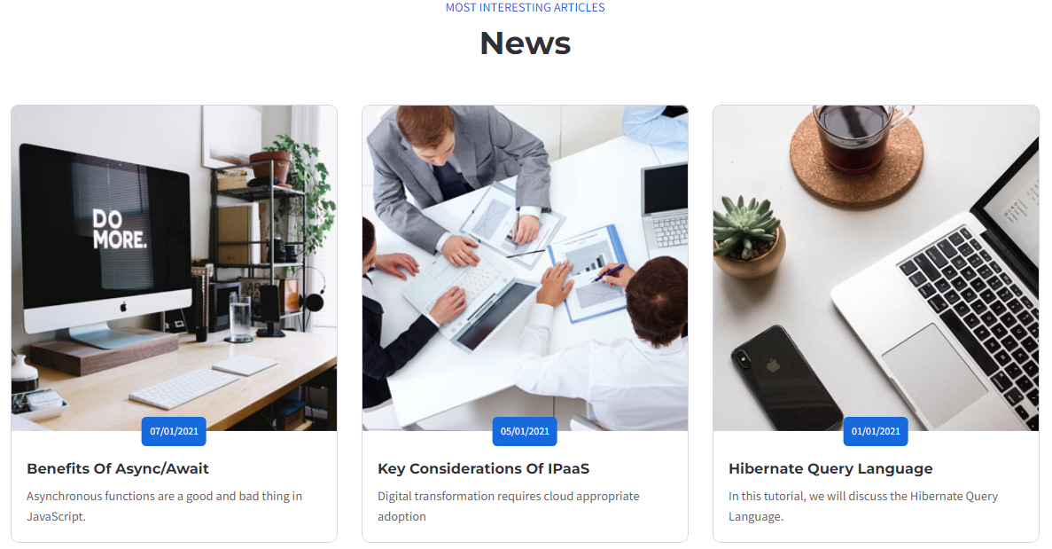

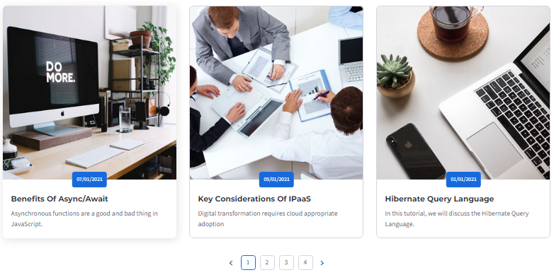

## Association members

The Association Members section will introduce the members of the Association. Member profiles and pictures need to be provided by the Association.

## Related Companies

The Related Companies section will display the information about the donor company. This section will include business links or a separate business card page.

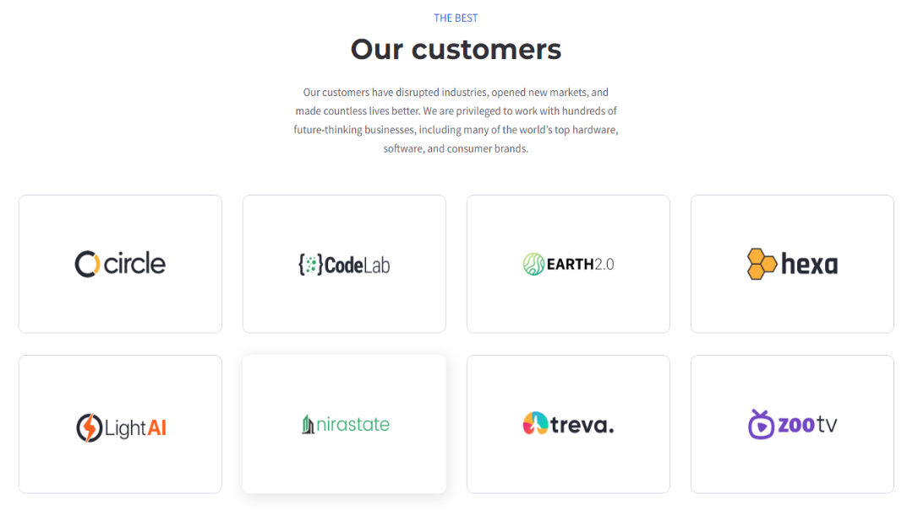

## Contact Us

The Contact Us section will allow the audience to send information to the Association's mailbox.

## Backstage Management

The Backstage Management section will allow Association members to register and log in. This section will also include the news and notice release management, and event display release management.

## Technology

The website will use the ASP.NET MVC Pattern and the Blazor framework for Web UI. It will also use MySQL for the database.

## Next step plan

The first version of the project plan is a preliminary page design, involving primary functions, and a technical description of the selected development. After that, there will be detailed design documents concerning user stories, class diagrams, and database diagrams. The next step will be to create a detailed design document for the website, including wireframes, design elements, and content.